

**UNIVERSITY OF GREENWICH**  
COMP1649 – Human Computer Interaction and Design

Coursework

|  |  |
| --- | --- |
| Student name | Chi-Trien Nguyen |
| ID number (00xxxxxxx) | 001353546 |
| Lecturer/Tutor name | Phuong Ha Dang Bui |
| Student submission date | November 15, 2023 |
| Word Count | 3282 words |

Table of Contents

1. Introduction 7

2. Background Literature 7

2.1. HCI Research 7

2.2. HCI Theory 7

**2.2.1.****Interaction design principles and interaction design patterns** 7

**2.2.2.****Investigation in cognitive psychology** 8

**2.2.3.****Interaction design theory** 8

**2.2.4.****Types of interaction and modes of interaction** 8

3. Design Process 9

3.1. Conceptual Design 9

**3.1.1.****User requirement** 9

**3.1.2.****Problem statement and design solutions** 9

**3.1.3.****Hierarchical model** 10

**3.1.4.****Conceptual model** 11

3.2. Design Principles 12

4. Prototype 12

4.1. Low-fidelity Prototype 12

4.2. Mid-fidelity Prototype 13

4.3. Physical Prototype 21

5. Research Study 21

6. Conclusion 23

References 24

Appendix A – The list of metaphors OceanicTrack plans to utilise 26

Appendix B – The questionnaires in the survey 27

Appendix C – The analysis of the responses of all survey takers 31

**Table of Figures**

*Figure 1: The hierarchical model* 9

*Figure 2: The conceptual model* 10

*Figure 3: Low-fidelity sign-in page* 11

*Figure 4: Low-fidelity register page* 11

*Figure 5: Low-fidelity homepage* 12

*Figure 6: Low-fidelity tracking list page* 12

*Figure 7: Low-fidelity media page* 12

*Figure 8: Account page of low-fidelity prototype* 12

*Figure 10: Start page* 13

*Figure 11: Sign-in page* 13

*Figure 12: Error message of the sign-in page* 13

*Figure 13: Sign-up page* 14

*Figure 14: Error message of the sign-up page* 14

*Figure 15: Homepage* 14

*Figure 16: Error message of the sign-up page* 14

*Figure 17: Tracking interface* 15

*Figure 18: Taking a photo while diving* 15

*Figure 19: Recording a video while diving* 15

*Figure 20: Tracking List page* 15

*Figure 21: The track before editing track* 15

*Figure 22: The track after editing track* 15

*Figure 23: Choose a person to share the track* 16

*Figure 24: Successfully shared track* 16

*Figure 25: Tracking list before deleting track 2* 16

*Figure 26: Tracking list after deleting track 2* 16

*Figure 27: Media page* 17

*Figure 28: Choose a person to share the media* 17

*Figure 29: Successfully shared media* 17

*Figure 30: Media list before deleting t1picture2.png* 17

*Figure 31: Media list after deleting t1picture2.png* 17

*Figure 32: Account page* 18

*Figure 33: Select an avatar to change* 18

*Figure 34: Successfully changed avatar* 18

*Figure 35: Edit email* 18

*Figure 36: Unsuccessfully edited email* 18

*Figure 37: Successfully edited email* 18

*Figure 38: Edit password* 18

*Figure 39: Unsuccessfully edited password* 18

*Figure 40: Successfully edited password* 18

*Figure 41: Edit name* 19

*Figure 42: Unsuccessfully edited name* 19

*Figure 43: Successfully edited name* 19

*Figure 44: Edit age* 19

*Figure 45: Unsuccessfully edited age* 19

*Figure 46: Successfully edited age* 19

*Figure 47: Edit gender* 19

*Figure 48: Unsuccessfully edited gender* 19

*Figure 49: Successfully edited gender* 19

*Figure 50: Edit phone number* 19

*Figure 51: Unsuccessfully edited phone number* 19

*Figure 52: Successfully edited phone number* 19

*Figure 53: The physical design* 20

*Figure 54: The questionnaires in the survey (1)* 26

*Figure 55: The questionnaires in the survey (2)* 26

*Figure 56: The questionnaires in the survey (3)* 27

*Figure 57: The questionnaires in the survey (4)* 27

*Figure 58: The questionnaires in the survey (5)* 28

*Figure 59: The questionnaires in the survey (6)* 28

*Figure 60: The questionnaires in the survey (7)* 29

*Figure 61: The questionnaires in the survey (8)* 29

*Figure 62: Question 1 in the survey* 30

*Figure 63: Question 2 in the survey* 30

*Figure 64: Question 3 in the survey* 30

*Figure 65: Question 4 in the survey* 31

*Figure 66: Question 5 in the survey* 31

*Figure 67: Question 6 in the survey* 31

*Figure 68: Question 7 in the survey* 32

*Figure 69: Question 8 in the survey* 32

*Figure 70: Question 9 in the survey* 32

*Figure 71: Question 10 in the survey* 33

*Figure 72: Question 11 in the survey* 33

*Figure 73: Question 12 in the survey* 33

*Figure 74: Question 13 in the survey* 34

**Table of Tables**

Table 1: The questionnaire that explains two project hypotheses 20

Table 2: Metaphor icons with the explanation of the coursework 25

1. **Introduction**

During the process of the development of the world, information technology is the most crucial part because it helps people to improve their lives and provide safety by fast calculations. Especially in a sport that is very risky and unsafe, diving needs to have the support of these fast technologies, and this is the reason for the appearance of a large number of applications for tracking activity nowadays. The research looks into the design process for GarminDIVE and DIVE Plus, two apps for recording dive activities. Even though these apps are popular among scuba divers, they need more features to deliver the optimum user experience. OceanicTrack is a prototype application designed to meet the demands of users that other apps cannot.

In this study, I will first conduct research about HCI (Human-Computers Interaction) according to (Cooper, et al., 2007) and (Hartson & Pyla, 2012), second is conceptual design, in third I will design the prototypes, the low-fidelity prototype using draw.io (diagram.net) and the mid-fidelity prototype (McElroy, 2017) using Axure RP 10. Then I will create a survey to make sure that my hypotheses are correct or not. Last but not least, I will analyze and evaluate the problems and provide the features that the application needs or maybe needs to improve.

1. **Background Literature**
   1. **HCI Research**

It is critical to harness the power of technology in order to support the diving sector's growing engagement in conservation and the Sustainable Development Goals (SDGs). Recreational dive computers, which record temperature and depth on a regular basis, are strong instruments that may enhance current monitoring systems across the world, particularly in under-sampled or highly variable coastal regions. These devices have shown to be useful in marine science for surveys, behavioral observations, and monitoring, opening the door for citizen scientific initiatives to be modernized (https://www.frontiersin.org/articles/10.3389/fmars.2023.1212790/full).

To harness the power of technology, this coursework project is to create an application name OceanicTrack with the purpose is SDGs. The main feature in the application is tracking and it provide for divers the parameters such as dive duration, ascent time, depth, temperature, the ability to see underwater (visibility), and oxygen in tank. Beside, this app support diver to take picture or recording during the dive, all pictures and videos will be store under the track name for easier to know which documents belong to a specific place.

* 1. **HCI Theory**
     1. **Interaction design principles and interaction design patterns**

Interaction design is the process of developing user experiences that improve communication and interaction in everyday life and at work, and it includes problems such as user interface design, software design, and interactive system design (Sharp, et al., 2019).

According to (Norman, 2002), the concept of technology, computers, and interfaces should be intuitive and straightforward, based on six principles: constraints, visibility, mapping, feedback, affordance, and consistency.

According to (Cremonesi, et al., 2015), a design pattern is a reusable solution to a common problem in software design, capturing solutions with a proven track record, not apparent solutions, and significant human components. The proposed conceptual structure by (Alexander, 1979) is also outlined in a formulation of design patterns: name, problem, context, forces, solution, rationale, example, and related pattern.

The project aims to implement Don Norman's Interaction Design principles: visibility, feedback, consistency, mapping, and affordance, with a specific emphasis on prioritizing user-centricity, ultimately creating a system that significantly improves the overall user experience.

* + 1. **Investigation in cognitive psychology**

The process of gaining information and comprehension through conscious and unconscious mental processes, such as perception, recognition, conception, reasoning, and memory, is known as cognition (aichatgpt, 2023).

Cognitive psychology explores human mental processes, including perception, attention, memory, and recognition (Lu & Dosher, 2007):

* **Perception** researchers delve into how individuals comprehend environmental information through sensory faculties and computer models.
* **Attention** impacts visual cortical activity, enhancing information processing and overall performance.
* **Memory** processes, examined through functional classification, involve experiments, computer models, brain imaging, and lesion investigations that indicate diverse processing systems.
* **Recognition**, a crucial aspect, involves categorizing events based on complexity, structural similarity, function, and conceptual theories.

The coursework is designed to enhance user experience and deepen understanding of human thought processes using insights from cognitive psychology, with a specific emphasis on the study of recognition.

* + 1. **Interaction design theory**

A conceptual model is a thorough explanation of the structure and functionality of a system, complete with linkages, mappings, design metaphors, and ideas. Through interaction and documentation, users build models, and by fine-tuning these models before user interface design, comprehension is enhanced based on (Johnson & Henderson, 2002).

Based on the information of (Madsen, 2000), Professionals see circumstances as part of their toolkit, expressing similarities and differences with metaphors. Their primary function is highlighting new or preexisting notions (Madsen, 2000).

Prototypes give the user interface (UI) concreteness for assessment and design; three approaches are available from RMP: storyboards for graphic design, UI testing, and visual description of activities in an envisioned system; paper prototypes; and online prototypes (Casaday & Rainis, 1996). Prototypes include (userfacet, 2022):

* **Low-fidelity Prototypes**: Rough wireframes and pencil and paper sketches of product features and components are the first tools design teams use to produce proof of concept.
* **Medium-fidelity Prototypes**: Using the wireframe, non-interactive mock-ups of websites with call-to-action icons, text, photos, and brand logos that are not clickable are produced.
* **High-fidelity Prototypes**: After usability testing, high-fidelity prototypes with clickable links and medium-quality mock-ups are utilised to assess the potency of visual design components.

The coursework focuses on user interactions, aesthetics, and usefulness while building interfaces and functional components for a diving application utilising low-fidelity and mid-fidelity (using Azure 10).

* + 1. **Types of interaction and modes of interaction**

(Buchanan, 1998) highlights function as a crucial design component, contrasts form with meaning and context and emphasises interaction in design frameworks. Types of interaction (Branco, et al., 2021):

* **Instructing**: This involves users providing input to a system, from entering instructions into a command line to vocalizing commands aloud.
* **Conversing**: This implies a dialogue between the user and the machine, fostering a more interactive and communicative interaction.
* **Manipulation**: Users are required to apply their knowledge of the surrounding world to navigate and interact with the interface, whether it's in a virtual or physical context.
* **Exploring**: This is defined as the system initiating a conversation with the user, allowing the user to decide whether or not to respond, creating a more dynamic and user-driven interaction.

With voice recognition and touch-controlled devices, Natural User Interaction (NUI) technology imitates human behaviour and makes basic customization and interaction possible (Hajraa, 2020):

* **Voice recognition**: With indoor and outdoor applications, speech recognition technology makes activities easier by offering voice instructions that are impacted by several elements, such as connectivity, processing activity, speed, surroundings, and reading errors.
* **Touch-controller**: Technological developments have a big impact on browsing experiences. They modify the screen dynamics when a phone is held and make design adjustments that emphasise the screen centre.

Underwater excursions become safer and more educated with the help of the diving software's instructing interaction mode, which improves user experience by allowing real-time inputs and lessons. The program is meant to be simple and easy to use, and it uses a touch controller that can be used on land and underwater.

1. **Design Process**
   1. **Conceptual Design**
      1. **User requirement**

Upon assessing the criteria, it is determined that OceanicTrack fulfils two essential user requirements:

* **Real-Time Diving Activity Tracking:** The system is set up to keep an eye on data about diving activities in real-time, giving users access to important updates and modifications right on their devices.
* **Taking Photos and Recording Videos:** With its straightforward user interface, adjustable parameters, and ideal environmental circumstances, the programme makes it easier to produce high-quality underwater photography and videography, even under challenging situations.

To improve the program's completeness, OceanicTrack users must also meet the following additional requirements:

* **Review and Diving Record**: A thorough dive log that is arranged chronologically should be available to users, making it simple to browse and update dive history.
* **Comfortable Mobile Application**: The smartphone app should work with popular platforms and be appropriate for inexperienced and seasoned divers. For convenience, it should have an easy-to-use interface and support offline dive recording.
  + 1. **Problem statement and design solutions**

The problem statement for the project is to develop an interactive underwater app tailored for snorkelers and scuba divers. The objective is to enrich underwater experiences, track diving activity, and balance usability and attractiveness, ensuring a seamless and engaging user experience.

The OceanicTrack product offers an interactive underwater and on-land experience for snorkelers and scuba divers, featuring a mobile app, waterproof attachments, and underwater tracking features:

* **Photo and Video Capture Underwater**: Enables users to snap pictures while submerging themselves quickly.
* **Real-Time Diving Activity Tracking**: Throughout the dive, the gadget has to monitor all necessary metrics, including ascent time, duration, and air in the tank.
* **Dive Review and Dive Log**: After a dive, programme users may go through their tracks. The settings, pictures, and videos they took throughout their dives will be visible to them.
* **User-Friendly Mobile App**: Whether they engage in onshore or underwater situations, the application's interface has to be simple to use and easy to notice.
  + 1. **Hierarchical model**

The figure 1 below shows the coursework's hierarchical model using the OceanicTrack program:

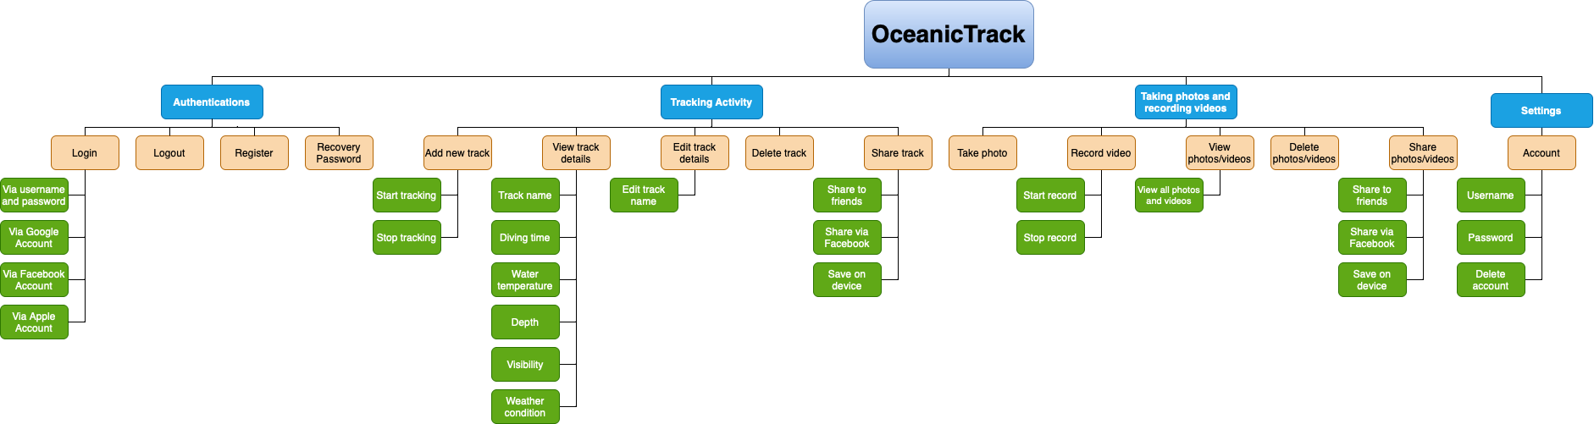

*Figure 1: The hierarchical model*

A diving program called OceanicTrack helps users both on land and underwater with authenticating by logging in, logging out, registering, and recovering passwords; tracking activity by adding, viewing, editing, deleting, and sharing tracks; taking photos and recording videos by taking, recording, viewing, deleting and sharing media; and setting functions.

* + 1. **Conceptual model**

The figure 2 below shows the coursework's hierarchical model using the OceanicTrack program:

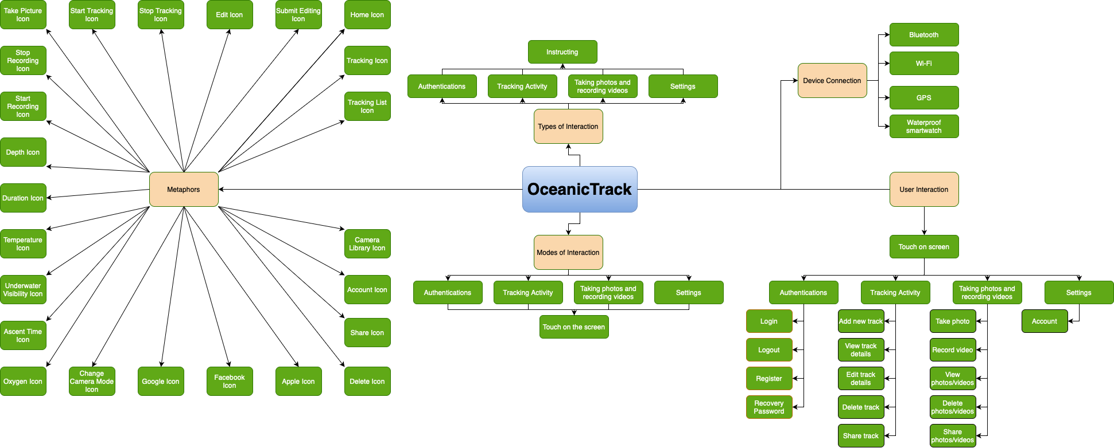

*Figure 2: The conceptual model*

OceanicTrack is a user-friendly software that makes underwater activities easier. To use, it requires a WiFi connection for tasks, a Bluetooth connection, a GPS connection for position, and a connection to a waterproof watch to monitor metrics. Standard symbols and distinctive icons are combined with a touchscreen interface to help users navigate the program's functionality. Some of the metaphor symbols displayed in the table below are *Appendix A*.

* 1. **Design Principles**

(Norman, 2002) states that the design of technology, computers, and interfaces should be simple and intuitive and should be founded on six principles:

* **Constraints**: It is essential to limit user interactions and prevent overwhelming options.
* **Visibility**: Improves user understanding; nevertheless, be aware that concealing items makes it more difficult to find and utilise them.
* **Mapping**: Refers to the process of linking the movements of controls to actual results.
* **Feedback**: Educates users on the results and application of their activities.
* **Affordance**: Illustrates the connection between the way something looks on the outside and how people utilise it and perceive it.
* **Consistency**: Creates interfaces that carry out comparable activities with standardised components and behaviours, using pre-established guidelines like standardised object selection processes.

The OceanicTrack design will incorporate the subsequent Nornam principles:

* **Visibility**: Important application buttons or icons will be positioned in clearly recognised areas with suitable colours or icons to draw the user's attention.
* **Mapping**: The pop-up of the function is displayed right at the user's location, helping them easily see the next steps to perform that function.
* **Feedback**: When users do activities, error or success notifications are sent to them so they can know what they've done.
* **Affordance**: Icons are crafted to closely emulate real-life objects and events, facilitating users in quickly predicting their functions.
* **Consistency**: To illustrate, the programme will use synchronised font size, colour schemes, and icon designs to facilitate speedy user navigation.

1. **Prototype**
   1. **Low-fidelity Prototype**

The features from figure 3 - 8 that showcase my OceanicTrack application's low-fidelity concepts:

* **Sign-in**:

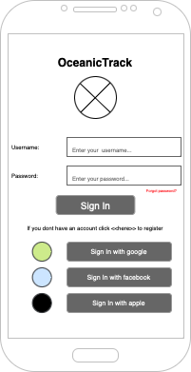

*Figure 3: Low-fidelity sign-in page*

* **Register**:

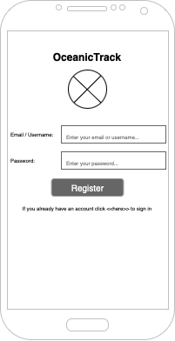

*Figure 4: Low-fidelity register page*

* **Homepage**:

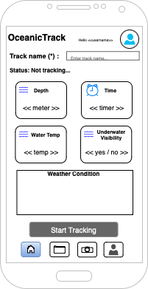

*Figure 5: Low-fidelity homepage*

* **Tracking list**:

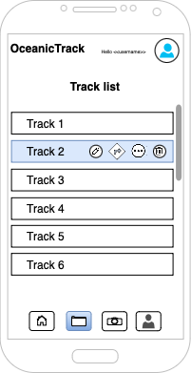

*Figure 6: Low-fidelity tracking list page*

* **Media:**

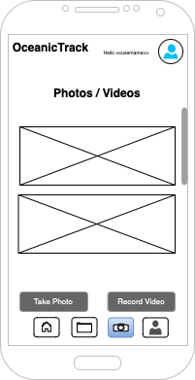

*Figure 7: Low-fidelity media page*

* **Account page**:

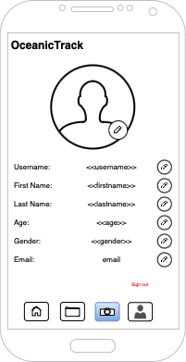

*Figure 8: Account page of low-fidelity prototype*

* 1. **Mid-fidelity Prototype**

The mid-fidelity prototype establishes detailed device pages and elucidates application functionalities through distinct features, ensuring user-friendly navigation and clarity in usage:

* **Start page**: When the program opens, the user is prompted to create a new account or log in with an existing one by clicking the button (using the touch mode interaction of (Hajraa, 2020)).

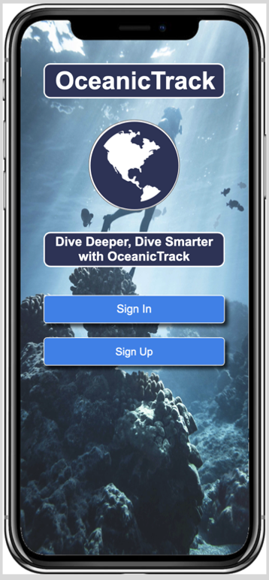

*Figure 9: Start page*

* **Sign-in page**: The user enters a username and password, receives an error if wrong using the Feedback principle of (Norman, 2002), and can log in with other accounts or visit the registration page. The homepage will appear if successful.

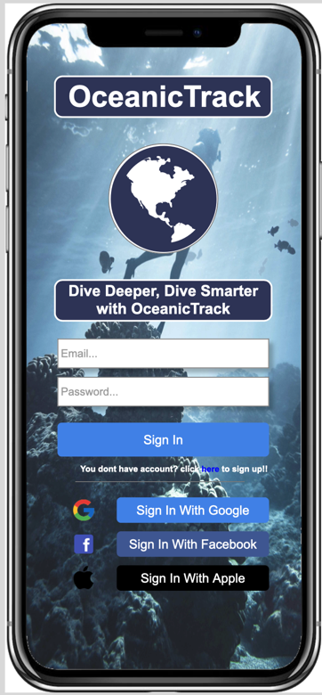

*Figure 10: Sign-in page*

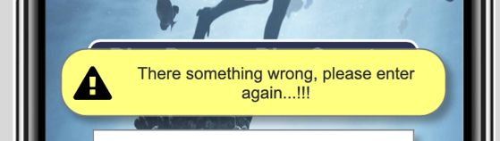

*Figure 11: Error message of the sign-in page*

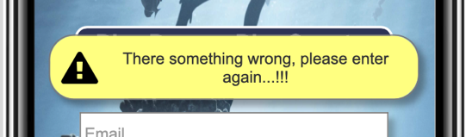

* **Sign-up page**: The user enters a username, password and re-password, receives an error if wrong, and leads them to the sign-in page to sign in.

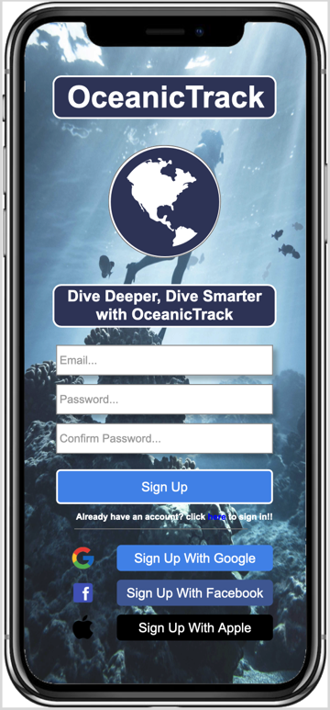

*Figure 12: Sign-up page*

**

*Figure 13: Error message of the sign-up page*

**

* **Homepage**: By entering the track name, clicking the play button, and stopping to save the track, users can start a new track; however, if the track name is not supplied, an error notice will show. By clicking on the symbols beneath the navigation, they may go between pages. Users can operate more rapidly with synchronised font size, colours, and icons using the Consistency principles of (Norman, 2002).

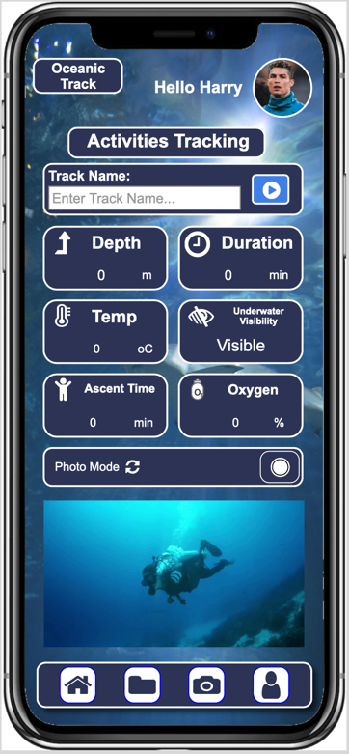

*Figure 14: Homepage*

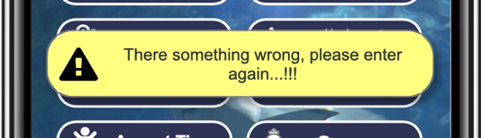

*Figure 15: Error message of the sign-up page*

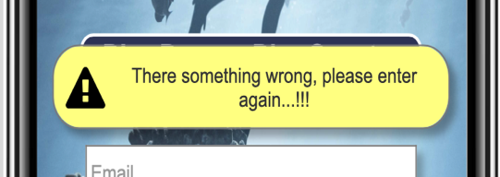

Users may watch and snap pictures while diving by inputting track names and hitting play, enabling real-time parameter execution following the instructing interaction of (Branco, et al., 2021).

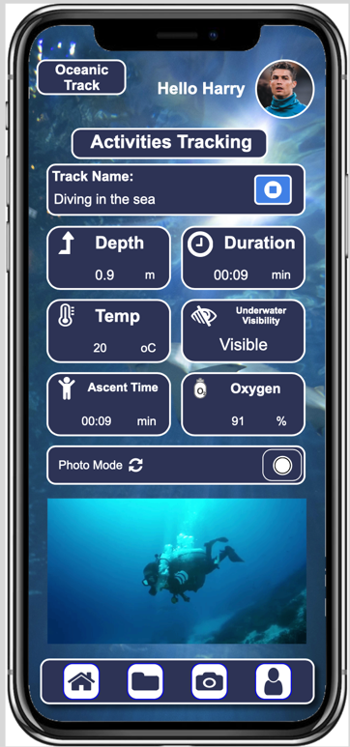

*Figure 16: Tracking interface*

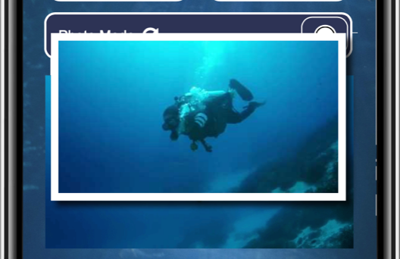

*Figure 17: Taking a photo while diving*

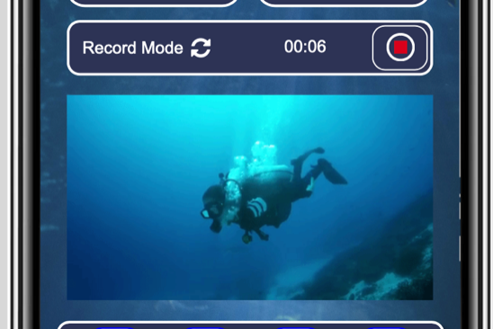

*Figure 18: Recording a video while diving*

* **Tracking List page**: Users can modify (the pencil icon), remove (the trash bin icon) using the Affordance principle of (Norman, 2002) and following the Metaphors of (Madsen, 2000), or distribute any tracks they've taken from this page. To make them more accessible for users to recognise, icons use colours that contrast with the system backdrop using the Visibility principle of (Norman, 2002).

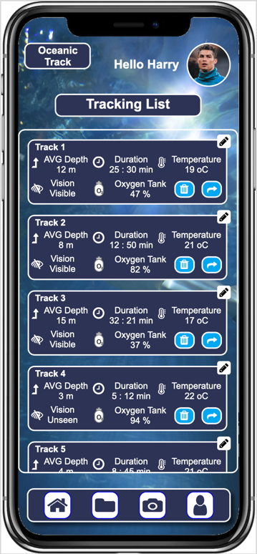

*Figure 19: Tracking List page*

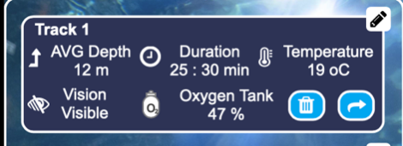

*Figure 20: The track before editing track*

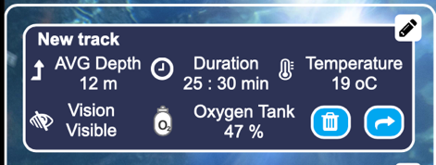

*Figure 21: The track after editing track*

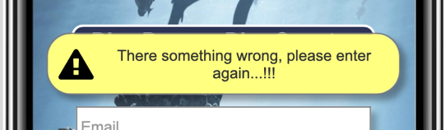

By selecting who to share a track with after clicking the share button on it, users may share tracks with their pals. That's where the pop-up table to select a sharer will appear, making it simple for people to utilise, using the Mapping principle of (Norman, 2002) and Recognition of Cognitive Psychology of (Lu & Dosher, 2007).

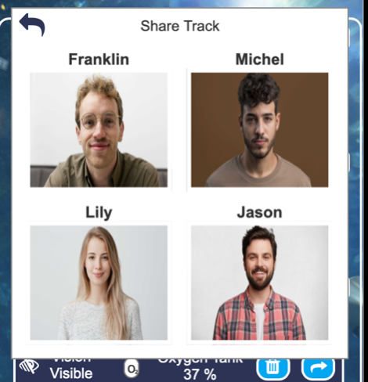

*Figure 22: Choose a person to share the track*

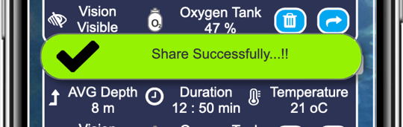

*Figure 23: Successfully shared track*



Or they can delete the track.

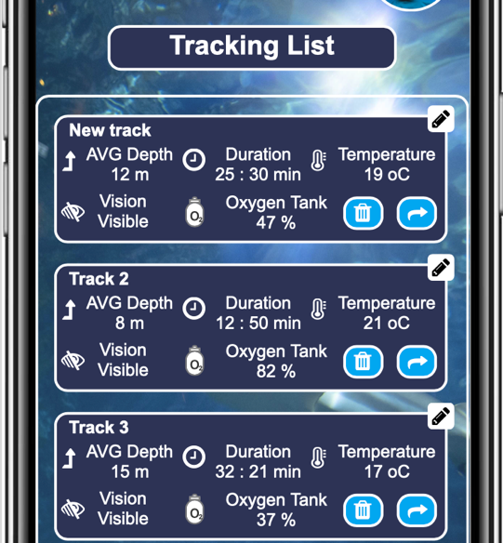

*Figure 24: Tracking list before deleting track 2*

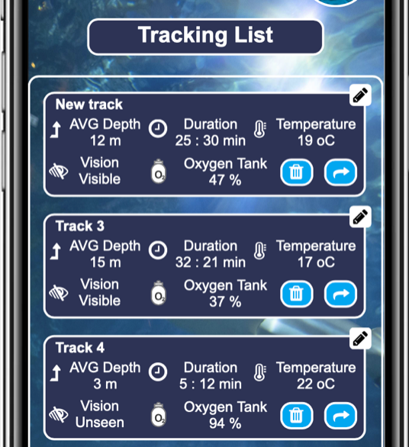

*Figure 25: Tracking list after deleting track 2*

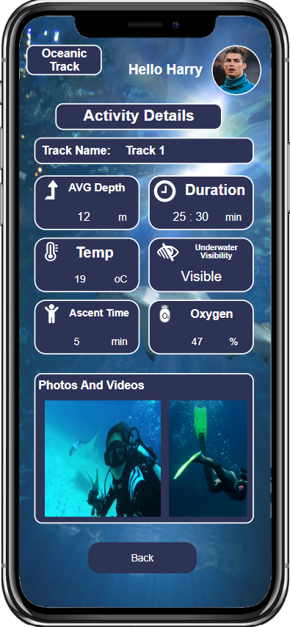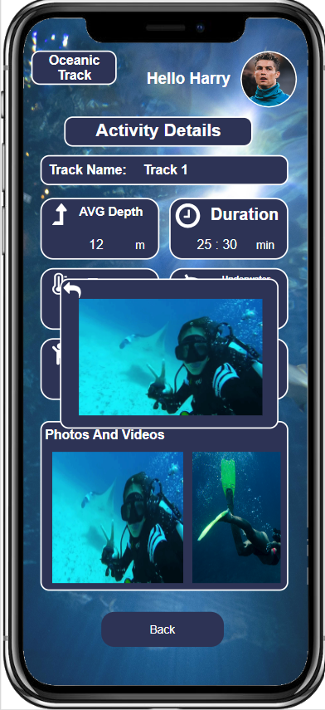

* **Media page**: All of the photos and videos that users take while diving are saved on this website, where they may be shared or deleted.

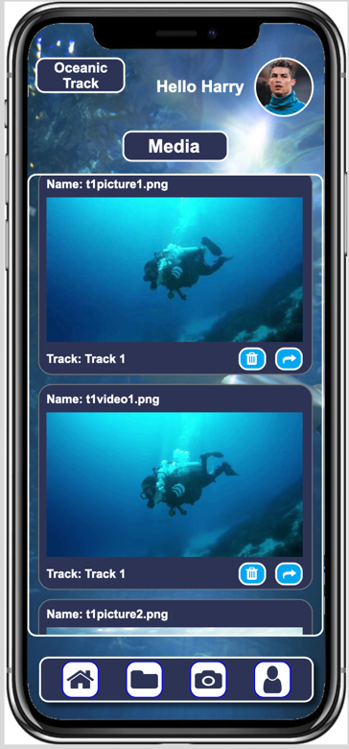

*Figure 26: Media page*



By selecting who to share a photo/video with after clicking the share button on it, users may share a photo/video with their pals.

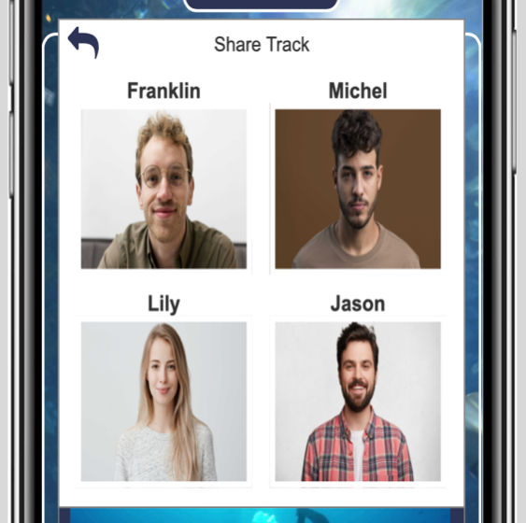

*Figure 27: Choose a person to share the media*

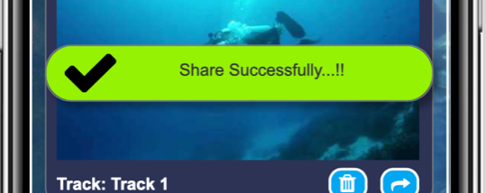

*Figure 28: Successfully shared media*

Or they can delete the video/photo.

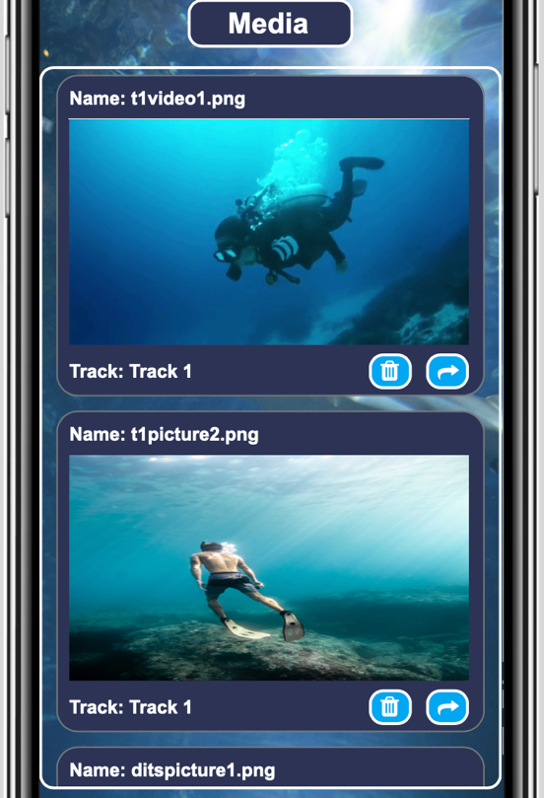

*Figure 29: Media list before deleting t1picture2.png*

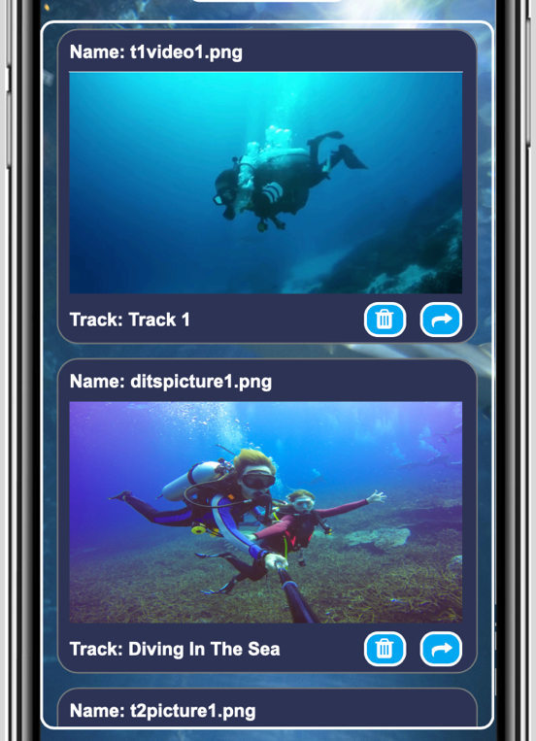

*Figure 30: Media list after deleting t1picture2.png*

* **Account Setting page**: Users may sign out or change all of their account details on this page.

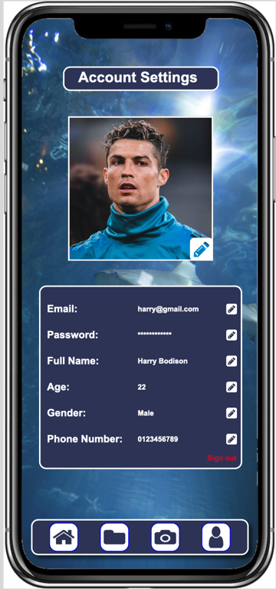

*Figure 31: Account page*

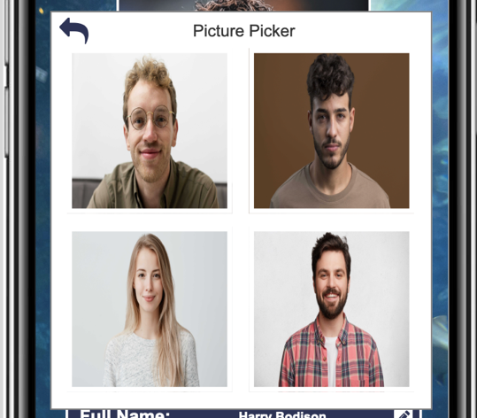

*Figure 32: Select an avatar to change*

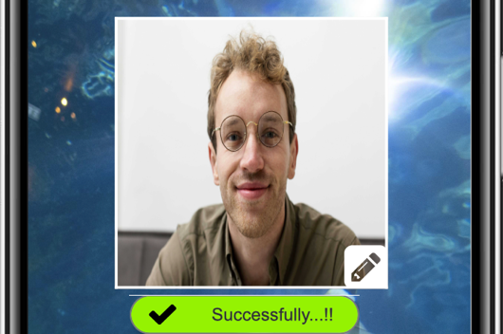

*Figure 33: Successfully changed avatar*

**

*Figure 34: Edit email*

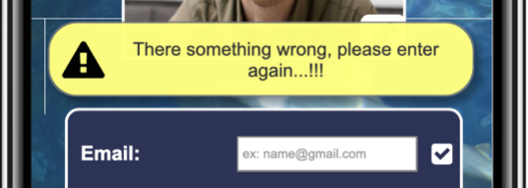

*Figure 35: Unsuccessfully edited email*

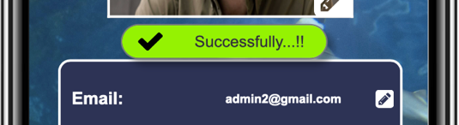

*Figure 36: Successfully edited email*

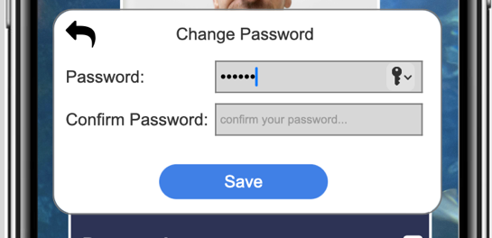

*Figure 37: Edit password*

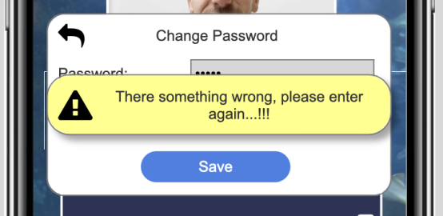

*Figure 38: Unsuccessfully edited password*

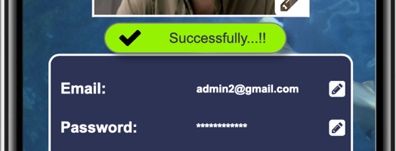

*Figure 39: Successfully edited password*

**

*Figure 40: Edit name*

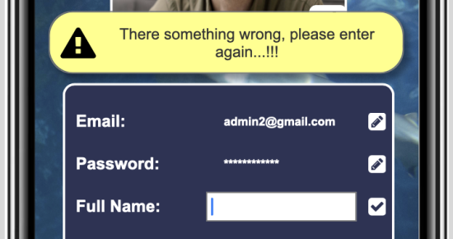

*Figure 41: Unsuccessfully edited name*

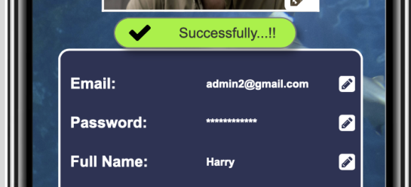

*Figure 42: Successfully edited name*

**

**

*Figure 43: Edit age*

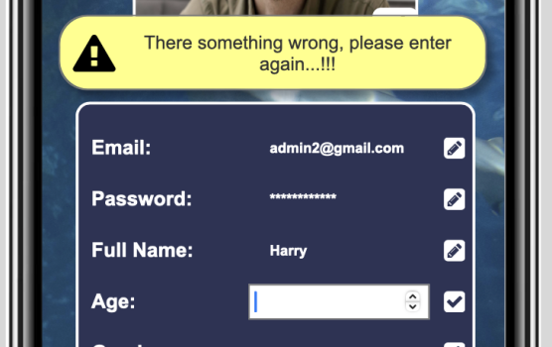

*Figure 44: Unsuccessfully edited age*

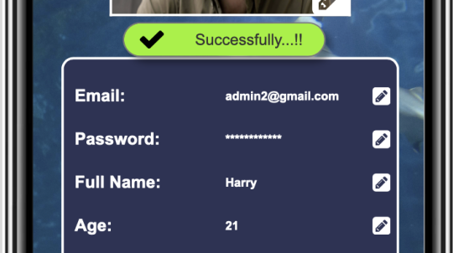

*Figure 45: Successfully edited age*

**

*Figure 46: Edit gender*

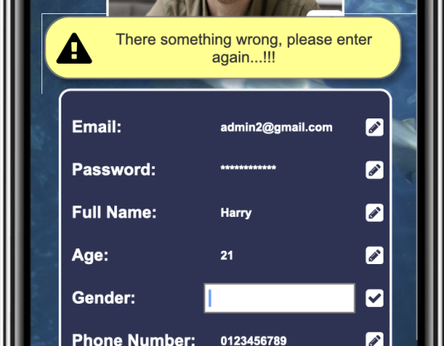

*Figure 47: Unsuccessfully edited gender*

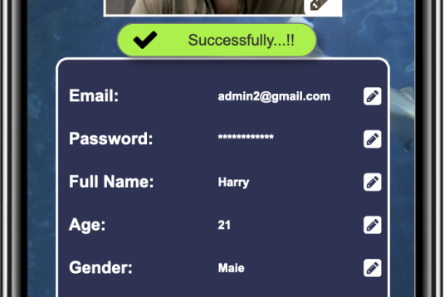

*Figure 48: Successfully edited gender*

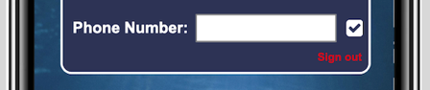

**

*Figure 49: Edit phone number*

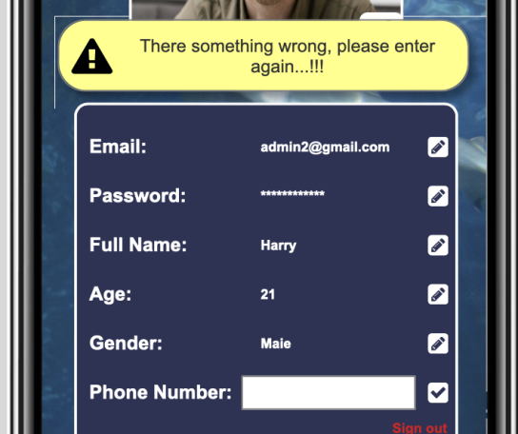

*Figure 50: Unsuccessfully edited phone number*

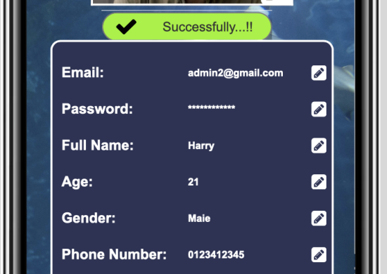

*Figure 51: Successfully edited phone number*

* 1. **Physical Prototype**

Below are the waterproof physical devices that are intended to be used to optimize this OceanicTrack diving application:

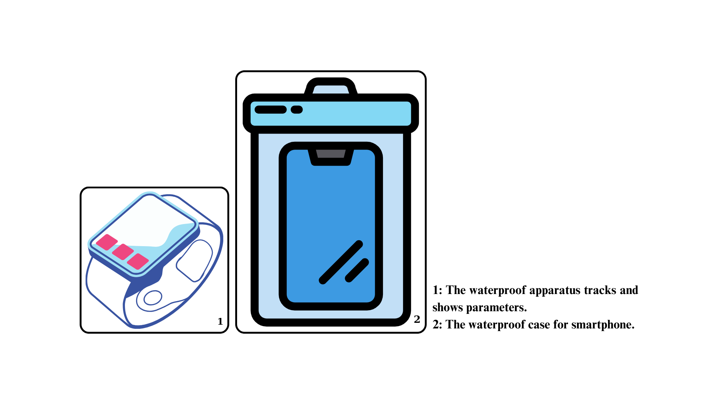

*Figure 52: The physical design*

The waterproof devices support track programs to provide:

* The water-resistant smartwatch serves as a monitoring tool and shows divers' parameters.
* Phones come with waterproof cases that make it easier for users to carry while diving and double as cameras for taking pictures and movies.

1. **Research Study**
2. **Conclusion**

Studying design principles, patterns, frameworks, and cognitive psychology from a theoretical perspective. In order to start developing applications, research has yielded the clearest understanding of interaction types and modalities. The best method for illustrating the foundation for high-fidelity design has been used in this application to apply low-fidelity, mid-fidelity, and physical design.

Even while the programme has so far had a lot of positive feedback, test users' thoughts on the poll above indicate that it has certain flaws, including the functionality of ABC and XYZ.

In order for the application to be developed in the best way, we need to fix and add functions such as ABC and XYZ to get a better experience.

This project will eventually produce a high-fidelity prototype that will be made available for purchase.

# **References**

Sharp, H., Preece, J. & Rogers, Y., 2019. *Interaction Design: Beyond Human-Computer Interaction.* 5th Edition ed. s.l.:Wiley.

Norman, D., 2002. *The Design of Everyday Things.* 1st ed. New York: Basic Books.

Lu, Z.-L. & Dosher, B. A., 2007. Cognitive psychology. *Scholarpedia,* 2(8), p. 2769.

Branco, R., Neves, M., Noriega, P. & Casais, M., 2021. An Interaction Design Analysis of Mood Trackers. In: N. Martins & D. Brandão, eds. *Advances in Design and Digital Communication.* Cham: Springer International Publishing, pp. 23-31.

Hajraa, A., 2020. *Natural User Experiences - Touch, Voice, Gesture, And More....* [Online]   
Available at: https://yourstory.com/mystory/natural-user-experiences-touch-voice-gesture  
[Accessed 12th October 2023].

Bhat, A., 2023. *Online Survey: What it is, advantages & examples.* [Online]   
Available at: https://www.questionpro.com/blog/what-are-online-surveys/  
[Accessed 3 November 2023].

Cremonesi, P., Elahi, M. & Garzotto, F., 2015. *Interaction Design Patterns in Recommender Systems.* New York, Association for Computing Machinery.

Alexander, C., 1979. *The Timeless Way of Building.* 1st ed. Oxford: Oxford University Press.

aichatgpt, 2023. *What is cognition in human computer interaction?.* [Online]   
Available at: https://aichatgpt.co.za/what-is-cognition-in-human-computer-interaction/#What_is_cognition_in_HCI  
[Accessed 16 November 2023].

Johnson, J. & Henderson, A., 2002. Conceptual Models: Begin by Designing What to Design. *Interactions,* 9(1), p. 25–32.

Madsen, K. H., 2000. *Magic by Metaphors.* New York, Association for Computing Machinery.

Casaday, G. & Rainis, C., 1996. *Requirements, Models, and Prototypes for HCI Design.* New York, Association for Computing Machinery.

userfacet, 2022. *What is a Prototype? 3 Most Important Types Of Prototypes.* [Online]   
Available at: https://www.userfacet.com/blog/what-is-a-prototype-3-most-important-types-of-prototypes  
[Accessed 17 November 2023].

Buchanan, R., 1998. Branzi's Dilemma: Design in Contemporary Culture. *Design Issues,* 14(1), pp. 3-20.

McElroy, K., 2017. *Prototyping for Designers: Developing the Best Digital and Physical Products.* 1st ed. California: O’Reilly Media.

Hartson, R. & Pyla, P., 2012. *The UX Book: Process and Guidelines for Ensuring a Quality User Experience.* 1st ed. CaliforCalifornia : Morgan Kaufmann.

Cooper, A., Reimann, R. & Cronin, D., 2007. *About Face 3: The Essentials of Interaction Design.* 3rd ed. New Jersey: Wiley.

# **Appendix A – The list of metaphors OceanicTrack plans to utilise**

Several metaphor symbols that will be utilised in the OceanicTrack project are included in the table below:

Table 2: Metaphor icons with the explanation of the coursework

|  |  |  |
| --- | --- | --- |
| **No.** | **Metaphor icons** | **Explanation** |
| 1 | Tracking List icon | To show the tracking list interface of the application |
| 2 | Tracking icon | To show the tracking function of the application |
| 3 | Home icon | To show the home interface of the application |
| 4 | Submit Editing icon | To show the submit editing function of the application |
| 5 | Edit icon | To show the edit function of the application |
| 6 | Stop Tracking icon | To show the stop tracking function of the application |
| 7 | Start Tracking icon | To show the start tracking function of the application |
| 8 | Take Picture icon | To show the take picture function of the application |
| 9 | Stop Recording icon | To show the stop recording function of the application |
| 10 | Start Recording icon | To show the start recording function of the application |
| 11 | Depth icon | To show the depth variable of the application |
| 12 | Duration icon | To show the duration variable of the application |
| 13 | Temperature icon | To show the temperature variable of the application |
| 14 | Underwater Visibility icon | To show the underwater visibility variable of the application |
| 15 | Ascent Time icon | To show the ascent time variable of the application |
| 16 | Oxygen icon | To show the oxygen variable of the application |
| 17 | Chang Camera Mode icon | To show the change camera mode function of the application |
| 18 | Google icon | To show the Google account of the application |
| 19 | Facebook icon | To show the Facebook account of the application |
| 20 | Apple icon | To show the Apple account of the application |
| 21 | Delete icon | To show the delete function of the application |
| 22 | Share icon | To show the share function of the application |
| 23 | Account icon | To show the account interface of the application |
| 24 | Camera Library icon | To show the camera library function of the application |

# **Appendix B – The questionnaires in the survey**